A PROJECT REPORT
ON

“TiffineService”

Submitted By
Mr. Shivtej Dipak Pawar
Mr.Vaibhav Subhash Satpute

Guided By

Mr.Kawade S.N.

In partial fulfilment of the award of the degree of
T.Y.B.Sc. (Computer Science) of
Sangamner Nagarpalika Arts, D.J.Malpani Commerce & B.N Sarda Science
College(Autonomous), Sangamner (Affiliated to Savitribai Phule Pune University)

DURING ACADEMIC YEAR

2024-2025



CERTIFICATE

This is to certify that, Mr. Shivtej Dipak Pawar and Mr.Vaibhav Subhash Satpute has completed the project on Tiffin Service Finder Management System as a partial fulfilment of T.Y.B.Sc. (Computer Science) laid down by the autonomous college affiliated to Savitribai Phule Pune University, satisfactorily during the academic Year 2024-2025.

Project Guide Head of the Department

Internal Examiner External Examiner

INDEX

Sr.No. | Title
1. | Acknowledgement.
2. | Introduction  - Problem Statement  - Objective of the System
3. | System analysis  - Existing systems  - Limitations of existing systems - Feasibility Study.
4. | Scope of the System
5. | Implementation details  - Software-Hardware specifications
6. | System Design  - Data Dictionary  - Entity Relationship Diagram  - System Model Using OOSE
7. | Coding
8. | Input-Output Screens and Reports
9. | Advantages and Future Enhancement of the System
10. | Bibliography and References

ACKNOWLEDGEMENT

A few words of gratitude to be inserted with project “Tiffine Service Finder ”. It is our earnest duty to express our thanks to all those who contributed directly or indirectly to our project.
Firstly, we would like to thank Sangamner Nagarpalika Arts, D. J. Malpani Commerce & B. N. Sarda Science College (Autonomous), Sangamner and Department of Computer Science for giving us an opportunity. Thanks to Dr.Laddha R. S. Vice Principal, Head of Department for his encouragement and valuable guidance.
We would like to thank Mr.Kawade S.N. who initiated us to complete this project and guided us timely. It is our privilege to express our gratitude to all staff members & non-Teaching Staff members for their excellent suggestions and active co-ordination.
And finally, we would like to thank all our friends for their support and the timely help.

Yours Sincerely,
Mr. PawerShivtej,
Mr.Satpute Vaibhav
T.Y.B.Sc.(Computer
Science)

INTRODUCTION

- Problem Statement: The modern lifestyle often leads to a demand for convenient, affordable, and healthy meal options. However, finding reliable tiffin services that meet individual dietary preferences canbechallenging.
The Tiffin Service Management System aims to connect users with nearby tiffin services based on location, cuisine preference, and ratings.

- Objective of the System:

- The objective is to develop a platform where users can:
- Search for tiffin services by location.
- View service details, including menu specializations.
- Rate and review services to help other users.
- Enable admins to manage tiffin services efficiently.

System Analysis

  - Existing Systems: Current solutions may involve WhatsApp groups, phone calls, or social media groups, which are inefficient and lack streamlined information.

- Limitations of Existing Systems:
Lack of proper feedback mechanisms.
Difficult to find services with specific dietary options.
Limited service tracking or management for admins.
  - Feasibility Study:
Technical Feasibility: Uses modern web technologies for a user-friendly interface.
Economic Feasibility: Affordable development with minimal operational costs.
Operational Feasibility: Provides a streamlined experience for both customer

Scope of the System
The system will:
• Help users locate tiffin services based on their location.
• Allow admins to manage service details efficiently.
• Support customer reviews and ratings to improve service quality.
• Include specializations such as vegetarian, vegan, or regional cuisines.

Implementation Details

Server Requirement:
The remmended minimum requirements are:
- PHP
- Postgres
- Apache
Browser Requirement:
The back-end administration requirements of Gantry in order of preference are as follows:
- FireFox4+
- Google Chrome 10+
Development Environment:
If developing a traditional web application that is to be accessed via the browser, the recommended approach is to deploy it to a web server and access it via http:// . Web server software is available free of charge for all operating systems. For Windows, IIS is recommended. On Mac OS and Linux, Apache is a popular option
The following is a list of suitable server setups that can be installed locally on your computer:
Linux
LAMP Bundle
XAMPP for Linux

SYSTEM DESIGN

Data Dictionary

- Admin

Field | Type | Size | Constraints
a_id | Integer | 11 | Primary key
name | Varchar | 50 | Not null
Email | Varchar | 255 | Not null,Unique
Password | Varchar | 255 | Not null

- Person

Field | Type | Size | Constraints
p_id | Integer | 11 | Primary key
name | Varchar | 50 | Not null
Email | Varchar | 255 | Not null
Phone_no | Varchar | 20 | Not null
address | Text | 20 | Not null
gender | Varchar | 10 | Not null
Password | Varchar | 255 | Not null

- location

Field | Type | Size | Constraints
L_id | Integer | 11 | Primary key
p_id | Integer | 11 | Primary key
name | Varchar | 50 | Not null
city | Varchar | 100 | Not null
state | Varchar | 100 | Not null
country | Varchar | 100 | Not null
P_code | Varchar | 20 | Not null

- TiffineService Table

Field | Type | Size | Constraints
t_id | integer | 11 | Primary key
p_id | Integer | 11 | foreign key ->person(p_id)
a_id | Integer | 11 | foreign key ->admin(A_id)
L_id | Integer | 11 | foreign key ->locations(L_id)
Created_at | Timestamp | - | Default:CURRENT_TIMESTAMP
name | Varchar | 50 | Not null
address | Text | - | Not null
city | Varchar | 100 | Not null
state | Varcha | 100 | Not null
Phone_no | Varchar | 20 | Not null
email | Varchar | 255 | Not null
specialities | Text | - | Unique
Website_link | varchar | 255 | Not null
Password | Varchar | 255 | Not null

- Specialization

Field | Type | Size | Constraints
S_id | integer | 11 | Primary key
name | varchar | 255 | Not null

- TiffineService Specialization

Field | Type | Size | Constraints
T_id | integer | 11 | Foreign key -  >(T-id)
S_id | integer | 11 | Foreign key -> Specializations(S_id)

- Rating

Field | Type | Size | Constraints
R_id | integer | 11 | Primary key
p_id | integer | 11 | foreign key -  >person(p_id)
H_id | integer | 11 | Foreign key -  >(T_id)
review | Text | - | NotNull

ER-Diagram

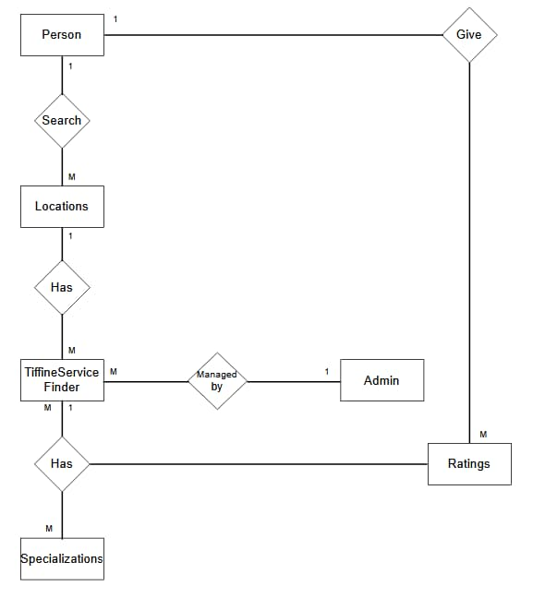
Use Case Diagram
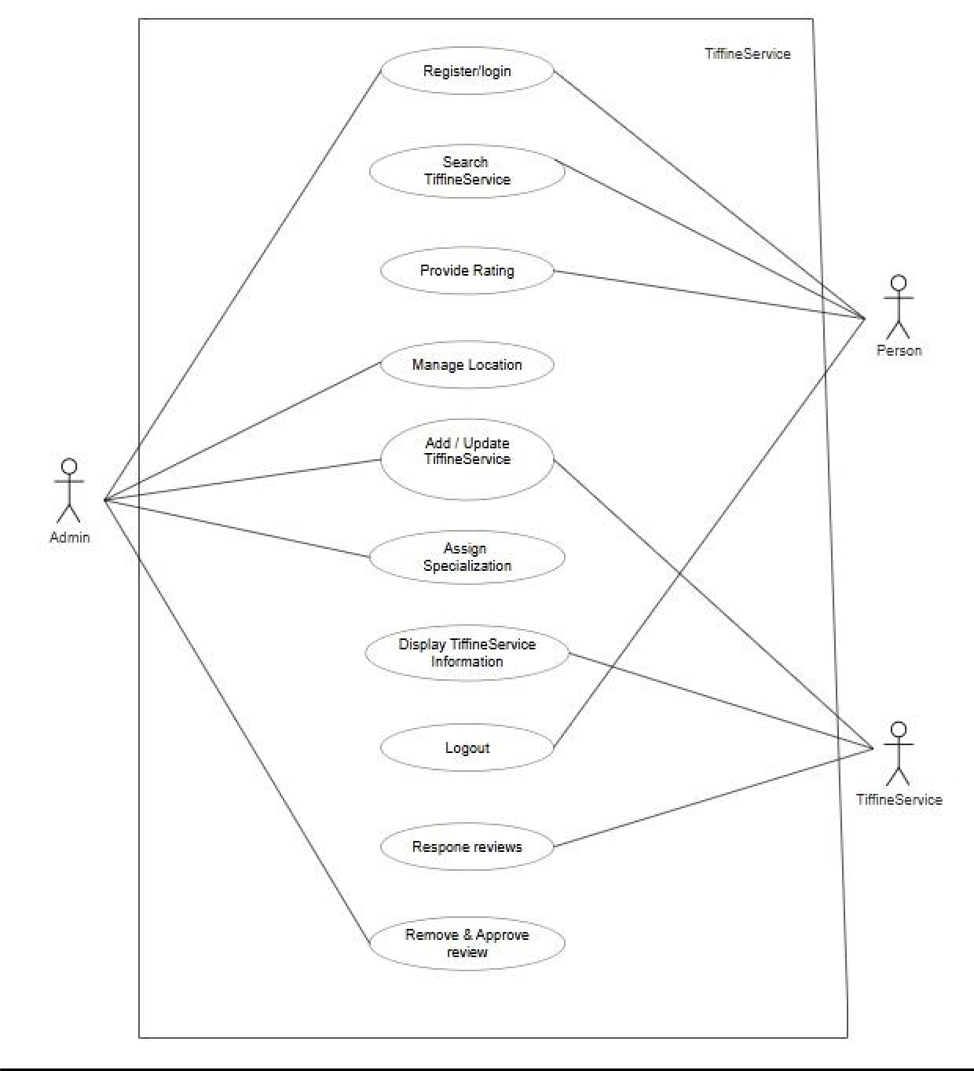
Class Diagram

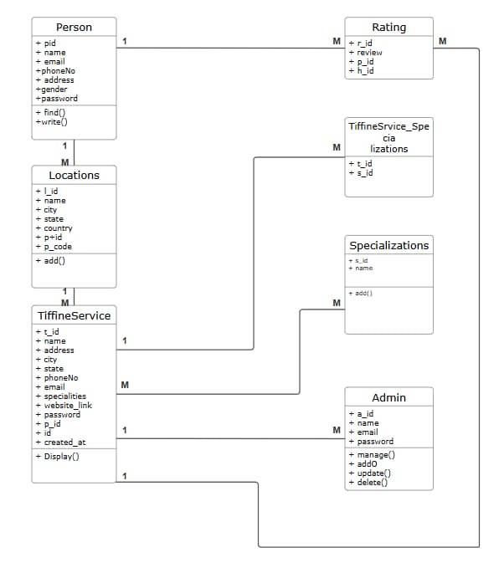
Activity Diagram

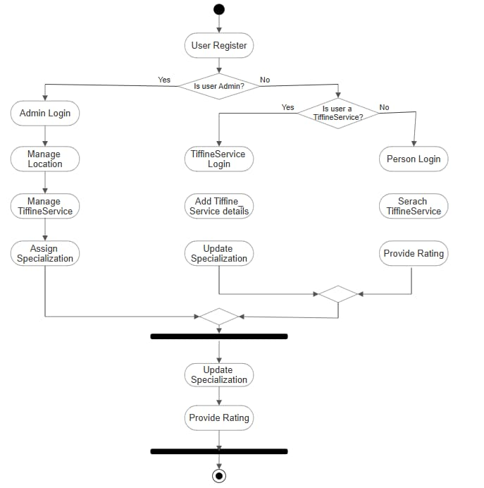
Sequence Diagram

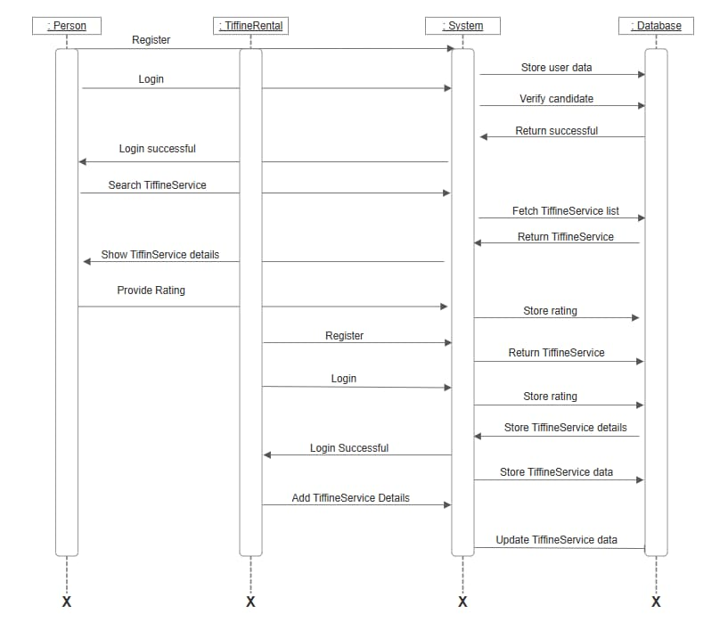

Deployment Diagram

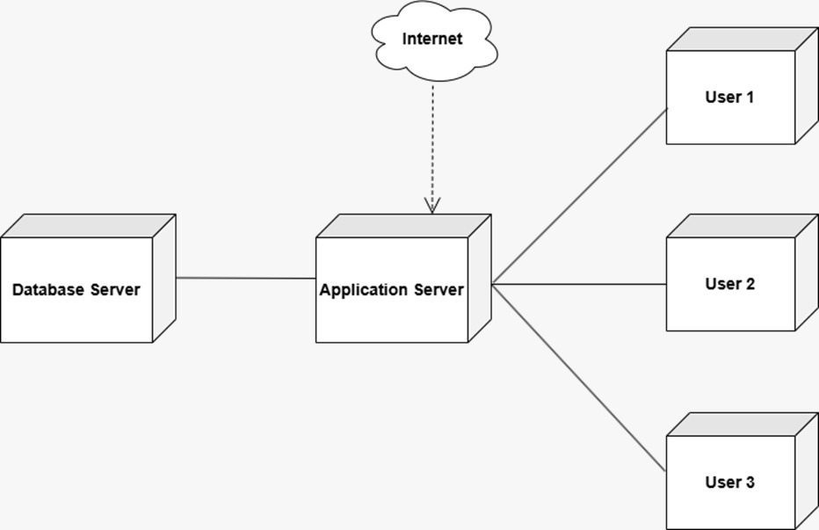

Coding:

- Admin Routes

$routes->get('/admin/login', 'AdminController::index'); // Show login page
$routes->post('/admin/login', 'AdminController::login'); // Handle login
$routes->get('/admin/logout', 'AdminController::logout'); // Logout

2.Admin Controller
<?php

namespace App\Controllers;

use App\Models\AdminModel;
use CodeIgniter\Controller;

class AdminController extends Controller
{
public function index()
{
return view('admin/admin_login'); // Loads the admin login view
}

public function login()
{
$session = session();
$adminModel = new AdminModel();

$email = trim($this->request->getPost('email')); // Trim spaces from input
$password = $this->request->getPost('password');

// Debugging Step - Check if email and password are received
if (empty($email) || empty($password)) {
return redirect()->back()->with('error', 'Email and Password are required.');
}

// Find admin by email (case insensitive)
$admin = $adminModel->where('LOWER(email)', strtolower($email))->first();

// If admin does not exist
if (!$admin) {
return redirect()->back()->with('error', 'Invalid Email or Password.');
}

// Check if password matches (plain text)
if ($password !== $admin['password']) {
return redirect()->back()->with('error', 'Invalid Email or Password.');
}

// Set session if login is successful
$session->set('admin_id', $admin['a_id']);
$session->set('admin_name', $admin['name']);

return redirect()->to('/tiffin_services'); // Redirect to tiffin services page
}

public function logout()
{
session()->destroy();
return redirect()->to('/admin/login');
}
}

3.Admin.Php

<?= $this->include('layouts/header') ?>

<!DOCTYPE html>
<html lang="en">
<head>
<meta charset="UTF-8">
<meta name="viewport" content="width=device-width, initial-scale=1.0">
<title>Admin Login</title>
<link href="https://stackpath.bootstrapcdn.com/bootstrap/4.5.2/css/bootstrap.min.css" rel="stylesheet">
<link href="https://fonts.googleapis.com/css2?family=Poppins:wght@300;400;500;600;700&display=swap" rel="stylesheet">
<script src="https://kit.fontawesome.com/a076d05399.js" crossorigin="anonymous"></script>

<style>
/* General Styles */
html, body {
height: 100%;
margin: 0;
padding: 0;
font-family: 'Poppins', sans-serif;
background: url("<?= base_url('uploads/bg2.jpeg') ?>") no-repeat center center fixed;
background-size: cover;
color: #2c3e50;
}

/* Content Area */
.content {
display: flex;
justify-content: center;
align-items: center;
height: 100vh;
}

.container {
background: white;
padding: 30px;
border-radius: 10px;
box-shadow: 0 10px 30px rgba(0, 0, 0, 0.1);
width: 400px;
margin-bottom: 70px;
}
h2 {
text-align: center;
font-weight: 600;
margin-bottom: 20px;
color: #007bff;
}

.error {
color: red;
text-align: center;
margin-bottom: 10px;
}

label {
font-weight: bold;
}

input {
padding: 10px;
border: 1px solid #ccc;
border-radius: 5px;
width: 100%;
}
button {
background: linear-gradient(135deg, #007BFF 0%, #0056b3 100%);
color: white;
border: none;
padding: 10px;
width: 100%;
border-radius: 5px;
font-weight: 600;
cursor: pointer;
margin-top: 15px;
}
button:hover {
background: #0056b3;
}
/* Sticky Footer */
footer {
background: linear-gradient(135deg, #2c3e50 0%, #1a252f 100%);
color: white;
padding: 1rem 0;
text-align: center;
position: fixed;

bottom: 0;
width: 100%;
}
</style>
</head>
<body>

<!-- Content Area -->
<div class="content">
<div class="container">
<h2>🔐 Admin Login</h2>

<?php if (session()->getFlashdata('error')): ?>
<p class="error"><?= session()->getFlashdata('error'); ?></p>
<?php endif; ?>

<form action="<?= site_url('/admin/login') ?>" method="post">
<label>Email:</label>
<input type="email" name="email" required>

<label>Password:</label>
<input type="password" name="password" required>

<button type="submit">Login</button>
</form>
</div>
</div>

<!-- Footer -->

<!-- Scripts -->
<script src="https://code.jquery.com/jquery-3.5.1.slim.min.js"></script>
<scriptsrc="https://cdn.jsdelivr.net/npm/@popperjs/core@2.5.2/dist/umd/popper.min.js">
</script>
<script
src="https://stackpath.bootstrapcdn.com/bootstrap/4.5.2/js/bootstrap.min.js">

</script>
</body>
</html
Inputs and Outputs Screens and Reports:
User Dashboard
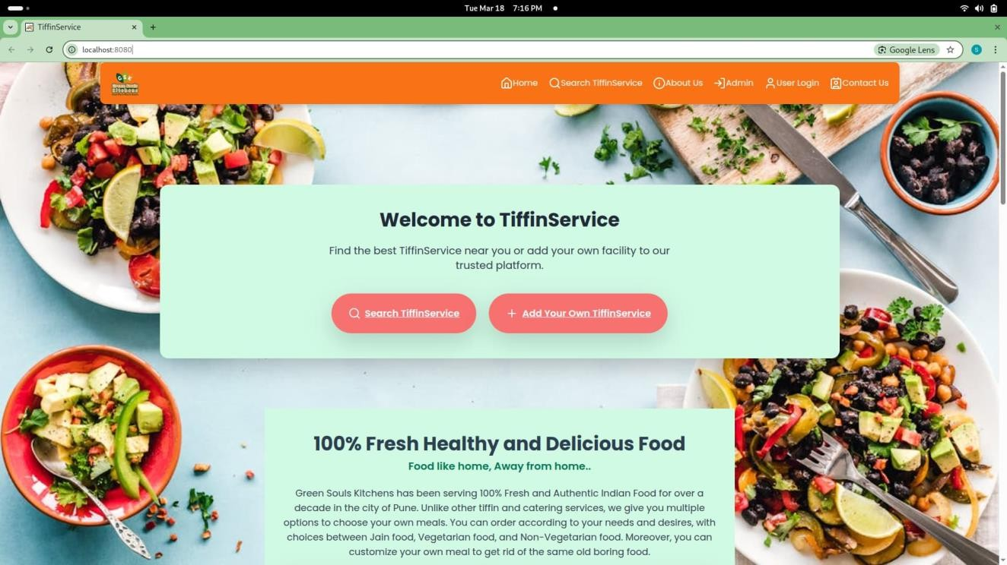

User Login
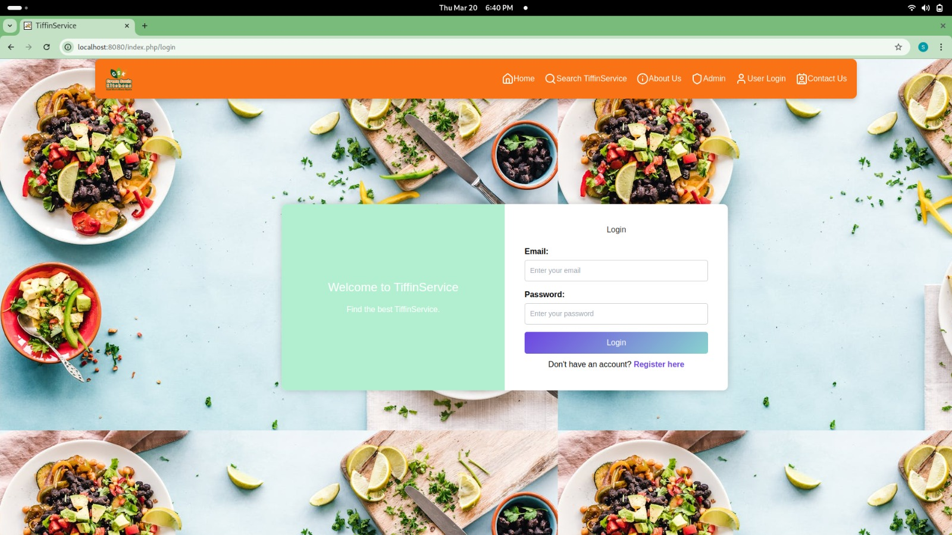

Find TiffinService
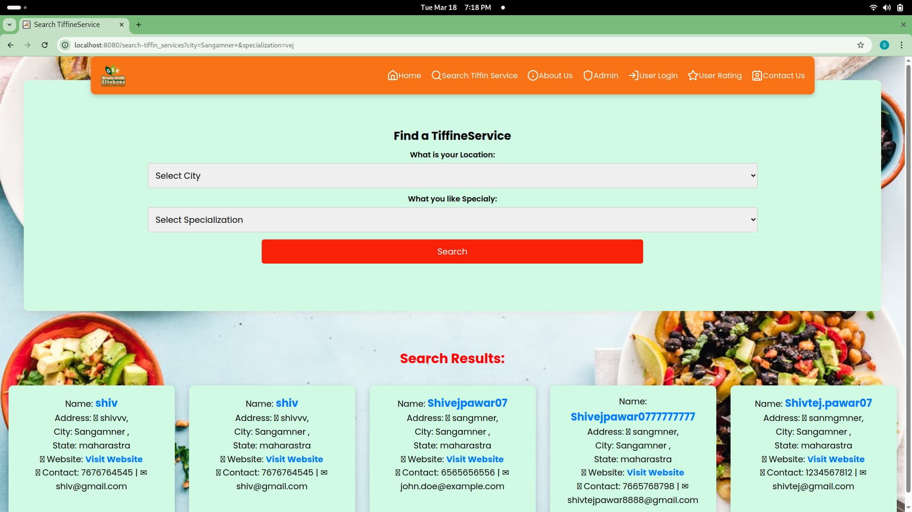

Total TiffinService
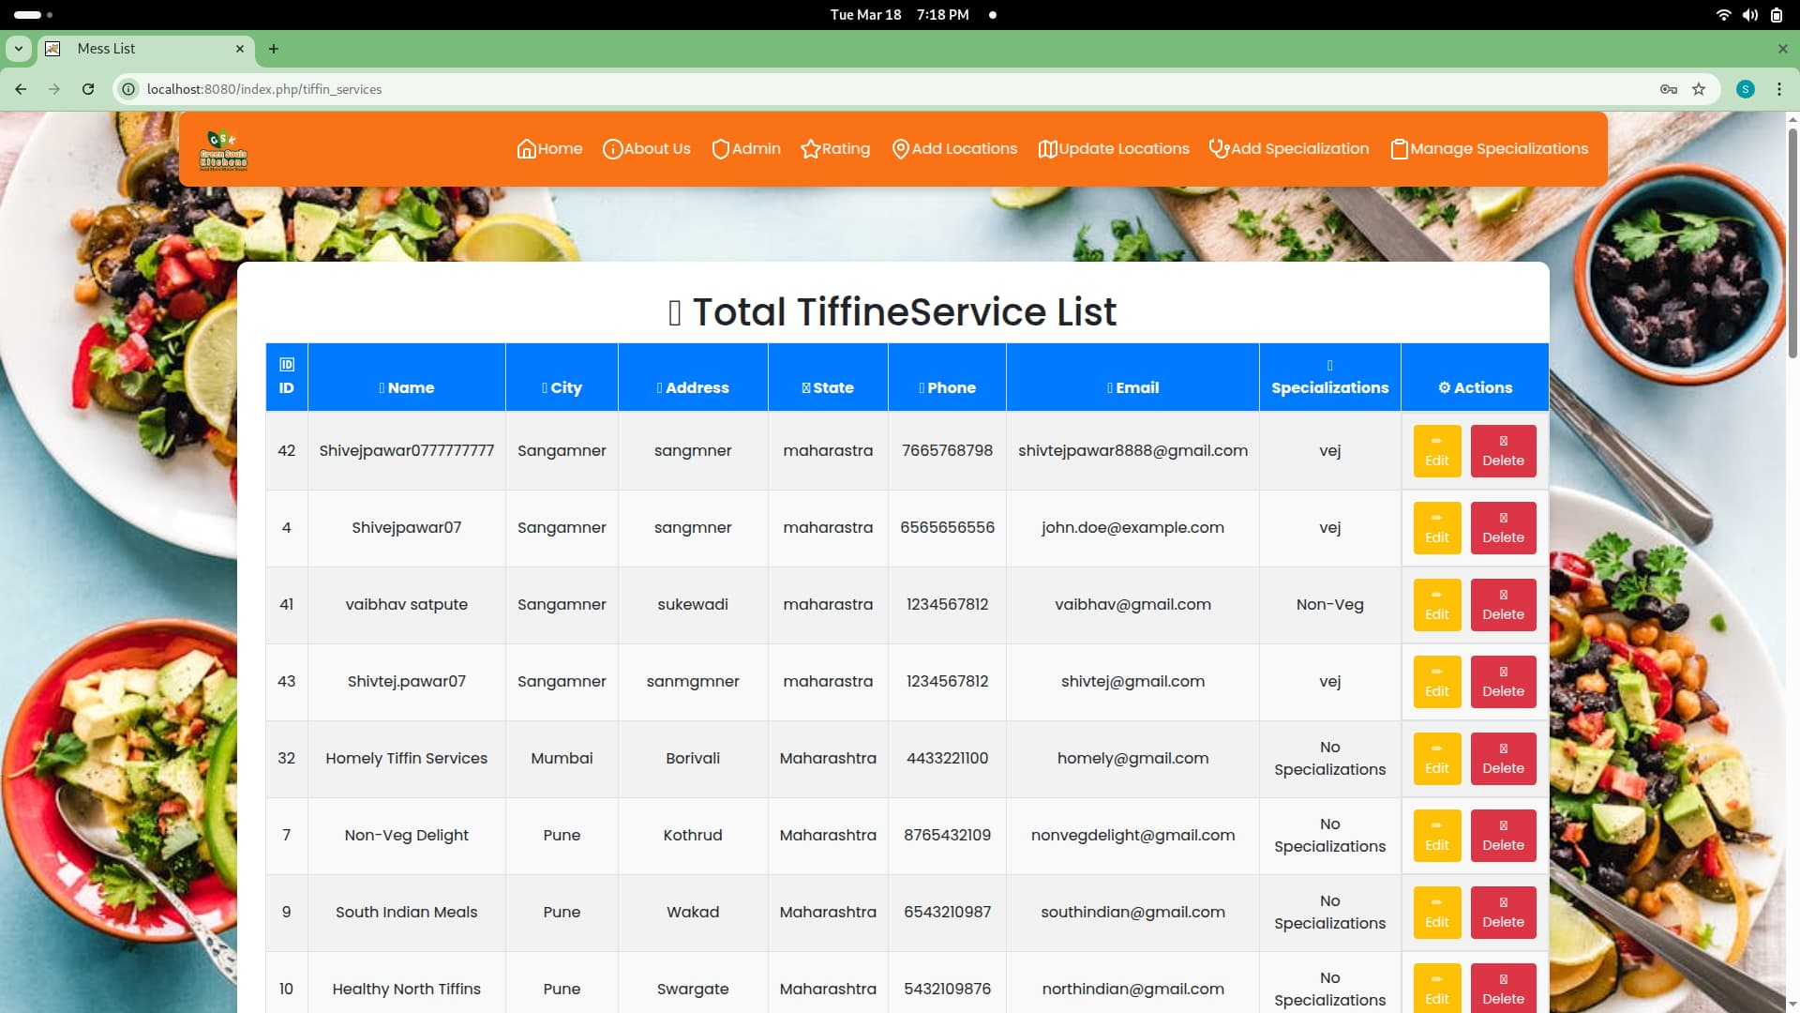

Ratting
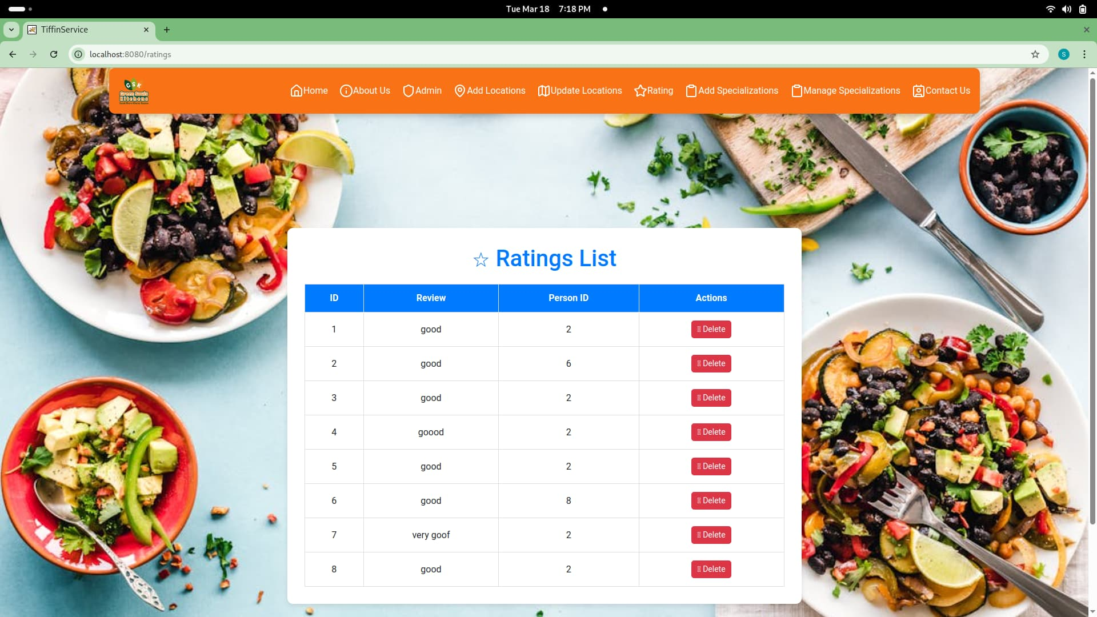

Contact us
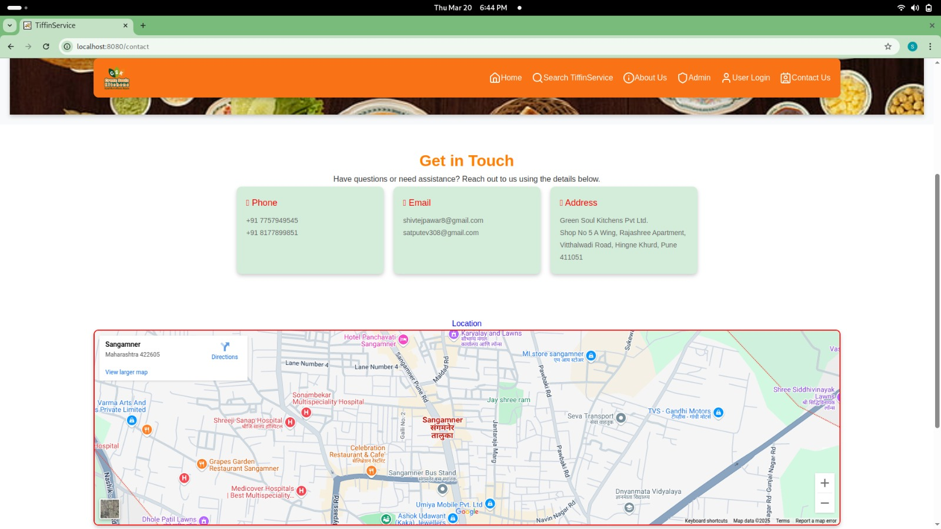

Advantages and Future Enhancements of the System
- Advantages

1.Convenience:
- Users can easily browse menus, place orders, and track deliveries through a single platform.
- Flexible subscription options (daily, weekly, or monthly) simplify meal planning.

2.Time-Saving:
- Eliminates the need to make calls or visit vendors physically.
- Quick access to multiple tiffin providers ensures faster decision-making.

3.Healthy Meal Choices:
- Customers can view detailed meal descriptions, including ingredients and nutritional information.

Future Enhancements of the System

- Integrate an AI algorithm that suggests meal options based on user preferences, past orders, and dietary needs.
- Personalized meal plans for individuals with specific health goals (e.g., weight loss, high protein diet).

Bibliography and References
- https://codeigniter.com

- Reference Books:
- Programming PHP By Rasmus Lerdorf and Kevin Tatroe, O'Reilly publication
- Beginning PHP 5 , Wrox publication
- PHP web sevices, Wrox publication
- AJAX Black Book, Kogent solution
- Mastering PHP , BPB Publication
- PHP cookbook, O'Reilly publication

